BUILDING AN AI AGENT
A Practical Handout for Getting Started with AI Tools

1. What Is an AI Agent?
An AI agent is a system built around a language model that can perceive a goal, decide on a sequence of actions, use external tools, and act autonomously to complete a task — rather than simply answering a single prompt. The defining loop is: observe → reason → act → observe the result → repeat until the goal is met.

2. Core Components
Component | Role
LLM (the reasoning core) | Interprets goals, plans steps, decides which tool to use next, and generates the final response
Tools / functions | APIs, code execution, search, databases, or other services the agent can call to act on the world
Memory | Short-term (conversation context) and long-term (stored facts, past outcomes) memory to maintain continuity
Planner / orchestrator | Breaks a goal into sub-tasks and sequences tool calls (may be the LLM itself or a separate control loop)
Guardrails / evaluation | Validation, permission checks, and human review steps that keep the agent's actions safe and correct

3. Step-by-Step: Building Your First Agent
- Step 1 — Define a narrow, well-scoped goal
- Step 2 — Choose a platform (see the comparison table below) based on your coding comfort and infrastructure needs
- Step 3 — Select or build the tools the agent needs (e.g., web search, a calculator, a database query, a file reader)
- Step 4 — Write a clear system prompt describing the agent's role, available tools, and boundaries
- Step 5 — Add memory only if the task genuinely requires it — start stateless and add complexity as needed
- Step 6 — Test with realistic tasks and log every tool call to catch reasoning errors early
- Step 7 — Add guardrails: confirmation steps for irreversible actions, rate limits, and human-in-the-loop review
- Step 8 — Iterate on the prompt and tool descriptions — most agent failures come from ambiguous instructions, not the model itself

4. Popular Tools and Frameworks
Tool / Platform | Best For | Notes
Claude (Agent SDK / API + tool use) | General-purpose agents with strong reasoning and native tool-calling | Good default starting point; supports computer use and MCP for external tools
LangChain / LangGraph | Custom multi-step workflows and graph-based agent logic | Steeper learning curve; large ecosystem of integrations
CrewAI / AutoGen | Multi-agent teams that collaborate on a task | Useful for role-based workflows (e.g., researcher + writer + reviewer)
OpenAI Assistants / Agents SDK | Quick prototyping with built-in retrieval and code tools | Managed infrastructure; less low-level control
n8n / Zapier / Make | No-code / low-code automation agents | Best for non-programmers connecting existing apps

5. Best Practices
- Start small: Keep the agent's goal narrow at first; broad, open-ended goals are harder to evaluate and debug.
- Describe tools clearly: Write tool descriptions the way you would instruct a capable new team member — the model relies entirely on this text to decide when to use each tool.
- Human oversight for high-stakes actions: Require explicit confirmation before actions that send, delete, or modify data.
- Measure performance: Track how often the agent picks the right tool, completes the task, and needs correction.
- Plan for failure and misuse: Treat any content the agent reads from the web or documents as untrusted input that could contain misleading instructions.

6. A Simple Worked Example
Goal: “Summarize this week's news on renewable energy and email me a digest.”
- Tool 1 — web search: retrieves recent articles on the topic.
- Tool 2 — summarizer (the LLM itself): condenses each article into 2–3 sentences.
- Tool 3 — email sender: drafts and sends the digest, with a confirmation step before sending.
The agent plans the sequence (search → summarize → draft → confirm → send), calling each tool in turn and adjusting if a step returns unexpected results.

7. Worked Example, Visually: Building It in n8n
The same renewable-energy digest agent from Section 6 can be assembled with no code in n8n by connecting nodes on a visual canvas. Each node is a step; data flows automatically from left to right.
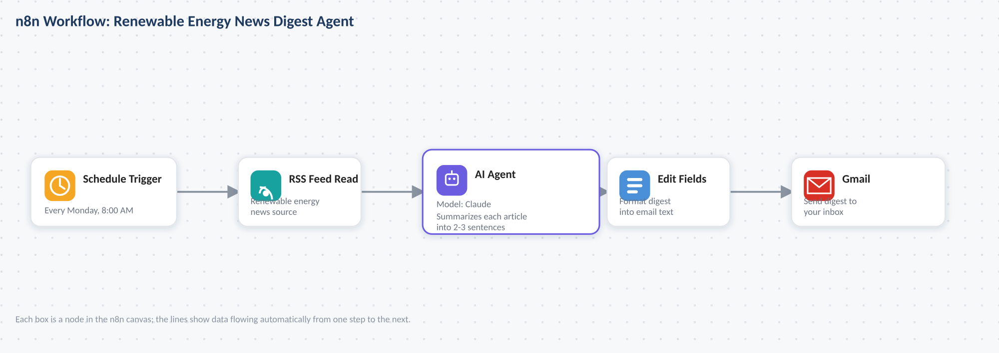
The five-node workflow: trigger → fetch news → summarize with AI → format → email.
- A Schedule Trigger starts the workflow automatically (e.g., every Monday morning).
- An RSS Feed Read node pulls the latest renewable-energy articles from a chosen source.
- An AI Agent node sends each article to Claude with a summarization prompt — shown in detail below.
- An Edit Fields node formats the summaries into a single readable digest.
- A Gmail node sends the finished digest to your inbox.
Opening the AI Agent node shows its configuration panel, where the model, prompt, and output limits are set:
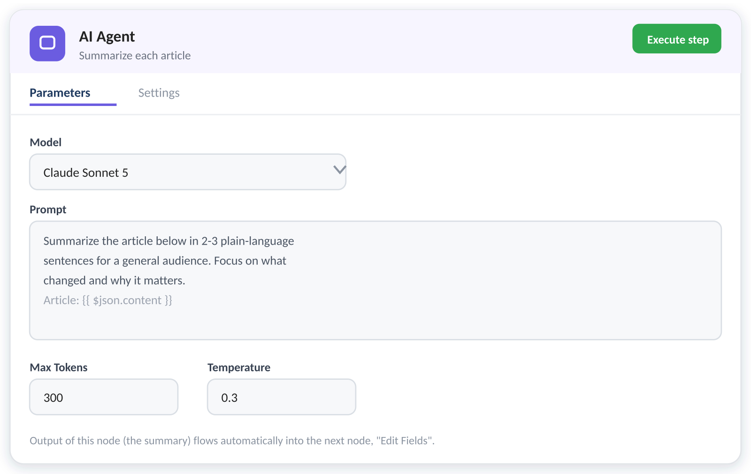
The AI Agent node's parameter panel — model, prompt, and generation settings.
Because n8n passes each node's output to the next node automatically, this whole pipeline runs unattended once it's built — the visual canvas doubles as both the design and the running agent.

